PYLOOM
Mapping Solution
How to place, connect and fill in the blocks for every question, at every level.

Easy level | 5 questions: E-Commerce Final Price, Palindrome Check, Restaurant Bill Split, Hashtag Generator, Server Temperature Alert
Medium level | 3 questions: Swap Locker Numbers, Employee Performance & Bonus Evaluator, School Supplies Budget
Hard level | 2 questions: World Landmark Locator, Weekly Attendance Chart

How to map a question on the canvas
- Drag the blocks listed for the question from the left panel onto the canvas.
- Type the question's input data into the Input block yourself. Each question below shows exactly what to enter.
- Connect the blocks by dragging from the output port (right side) of one block to the input port (left side) of the next.
- Fill in the value fields shown on the blocks (Operand, Key, Operator, Format and so on). Fields marked (leave empty) stay empty.
- Where a block has two incoming connections, the order can matter (for example Compare). The diagrams mark this as 1st and 2nd.
- Click Run Flow and compare the result with the expected output, then submit.

Reading the diagrams
- Each block card shows its type in the coloured header and its value fields underneath.
- Yellow text is the value you type into that field.
- Red 1st / 2nd badges on an arrow mean: connect that arrow first or second.

Easy level

Question 1: E-Commerce Final Price
An e-commerce store offers a flat ₹100 discount on a purchase, followed by an 18% GST applied to the remaining amount. Calculate the final price.
Input data | 1500
Expected output | 1652.0
Blocks needed | Input, Subtract, Multiply, Round, Output

Step 1 - Enter the input value
Drag an Input node, open ⚙ and set Input Data to 1500 (the original cart value).
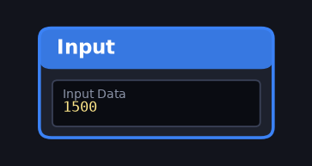
Input block with the value entered

Step 2 - Map and fill in the blocks
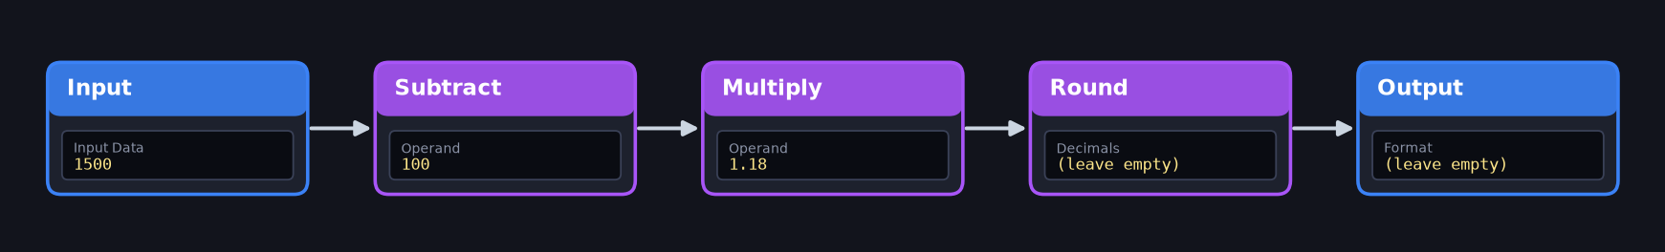
Completed canvas: block connections and field values
- Input → Subtract: open Subtract ⚙ and set Operand = 100 (flat discount).
- Subtract → Multiply: set Operand = 1.18 (adds 18% GST to the remaining amount).
- Multiply → Round: no settings needed (keeps 2 decimals).
- Round → Output.

Step 3 - Check the output
Leave the Output format empty. Run Flow must show 1652.0.
Tip: Connection order matters: subtract the discount first, then add the GST. Doing it the other way round gives 1770.0.

Question 2: Palindrome Check
Given a string, check if it reads the same backward as forward (a palindrome).
Input data | radar
Expected output | True
Blocks needed | Input, Reverse, Compare, Output

Step 1 - Enter the input value
Drag an Input node and set Input Data to radar.
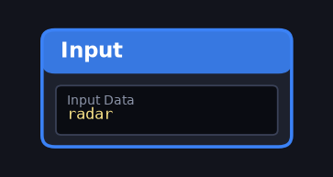
Input block with the value entered

Step 2 - Map and fill in the blocks
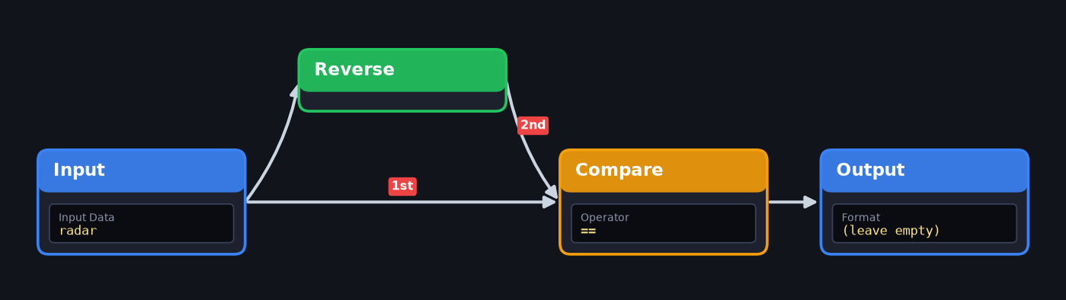
Completed canvas: block connections and field values
- Input → Reverse (reverses the text).
- Input → Compare (carries the original word).
- Reverse → Compare (carries the reversed word). Open Compare ⚙ and set Operator = ==.
- Compare → Output.

Step 3 - Check the output
Leave the Output format empty. Run Flow must show True (a palindrome).
Tip: The Compare block has two inputs. Connect Input to Compare first (the original word), then Reverse to Compare (the reversed word).

Question 3: Restaurant Bill Split
A group receives a restaurant bill. Add a 10% tip to the total amount, then divide it equally among 4 friends to find each person's share.
Input data | 2000
Expected output | 550.0
Blocks needed | Input, Multiply, Divide, Round, Output

Step 1 - Enter the input value
Drag an Input node and set Input Data to 2000 (total bill).
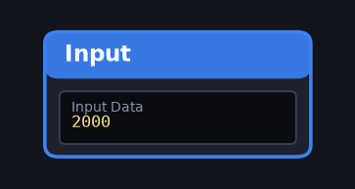
Input block with the value entered

Step 2 - Map and fill in the blocks
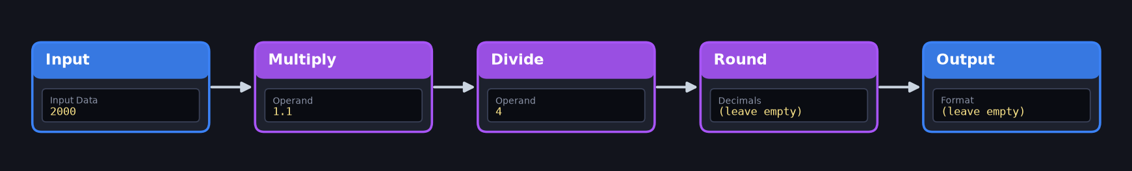
Completed canvas: block connections and field values
- Input → Multiply: set Operand = 1.1 (bill + 10% tip).
- Multiply → Divide: set Operand = 4 (four friends).
- Divide → Round (2 decimals).
- Round → Output.

Step 3 - Check the output
Leave the Output format empty. Run Flow must show 550.0.
Tip: Type 1.1 (not 10%) in Multiply. The Divide operand is the number of friends.

Question 4: Hashtag Generator
Convert a topic phrase into a valid single-word social media hashtag by removing all spaces, converting the text to uppercase, and adding # at the beginning.
Input data | python coding
Expected output | #PYTHONCODING
Blocks needed | Input, Replace, Uppercase, Output

Step 1 - Enter the input value
Drag an Input node and set Input Data to " python coding " (keep the spaces at both ends; quotes are optional).
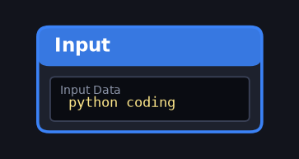
Input block with the value entered

Step 2 - Map and fill in the blocks
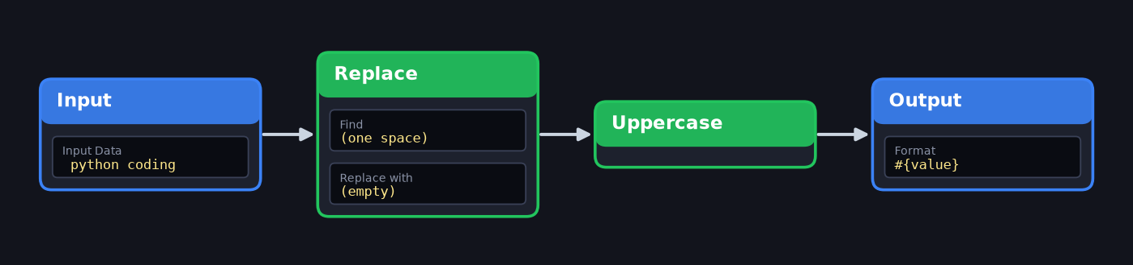
Completed canvas: block connections and field values
- Input → Replace: open Replace ⚙, Find = one space character, Replace With = empty (delete the text in the box).
- Replace → Uppercase.
- Uppercase → Output.

Step 3 - Check the output
Set the Output format to #{value}. Run Flow must show #PYTHONCODING.
Tip: In Replace, the Find box must contain exactly one space character and the Replace with box must be empty. The Output format is #{value}.

Question 5: Server Temperature Alert
A server monitoring tool tracks system temperature. Convert the reading from Fahrenheit to Celsius, then check if the temperature exceeds the safe threshold of 40°C. Formula: C = (F - 32) * 5 / 9.
Input data | 113
Expected output | True
Blocks needed | Input, Subtract, Multiply, Divide, Compare, Output

Step 1 - Enter the input value
Drag an Input node and set Input Data to 113 (temperature in °F).
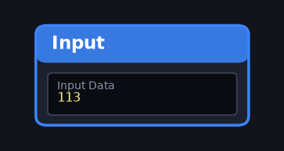
Input block with the value entered

Step 2 - Map and fill in the blocks
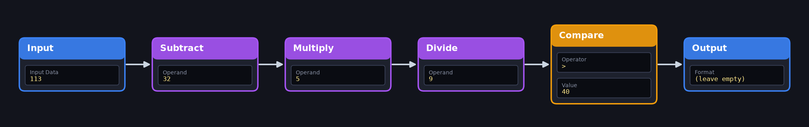
Completed canvas: block connections and field values
- Input → Subtract: Operand = 32.
- Subtract → Multiply: Operand = 5.
- Multiply → Divide: Operand = 9 (the value is now the Celsius reading, 45).
- Divide → Compare: set Operator = > and Value = 40 (safe threshold).
- Compare → Output.

Step 3 - Check the output
Leave the Output format empty. Run Flow must show True (45°C > 40°C).
Tip: The Celsius value is 45 after the Divide block. Compare then checks 45 > 40, so the answer is True.

Medium level

Question 1: Swap Locker Numbers
Two students are assigned the wrong locker numbers. Create a workflow that swaps Student A and Student B's locker numbers.
Input data | {"student_a_locker":12,"student_b_locker":25}
Expected output | Student A locker = 25 / Student B locker = 12
Blocks needed | Input, Output

Step 1 - Enter the input value
Drag an Input node and set Input Data to the JSON {"student_a_locker": 12, "student_b_locker": 25}.
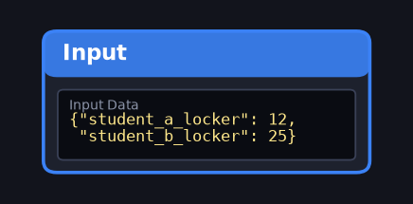
Input block with the value entered

Step 2 - Map and fill in the blocks
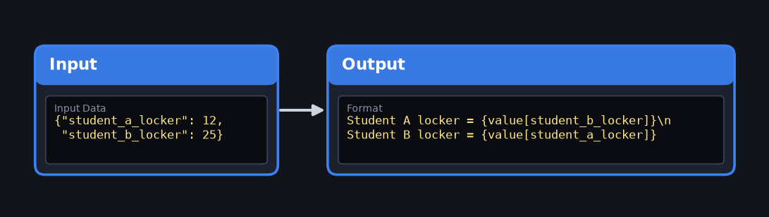
Completed canvas: block connections and field values
- Input → Output (one connection). The swap happens in the Output format, where A takes B's value and B takes A's.

Step 3 - Check the output
Set the Output format to: Student A locker = {value[student_b_locker]}\nStudent B locker = {value[student_a_locker]} (type \n where the line break goes). Run Flow must show the two swapped lines.
Tip: Only two blocks are needed. The swap is done inside the Output format: A takes B's value and B takes A's. Type \n where the line break goes.

Question 2: Employee Performance & Bonus Evaluator
An HR evaluation tool computes employee monthly bonuses based on score ratings and extra project hours. Base Bonus = Extra Hours * $25. If Rating >= 4.5, double the base bonus (* 2.0); otherwise keep it unchanged (* 1.0). Add a fixed $100 attendance allowance to the final evaluated bonus.
Input data | {"employee_name":"Sarah","rating_score":4.8,"extra_hours":10}
Expected output | 600.0
Blocks needed | Input, Get, Multiply, IfElse, Add, Output

Step 1 - Enter the input value
Drag an Input node and set Input Data to {"employee_name": "Sarah", "rating_score": 4.8, "extra_hours": 10}.
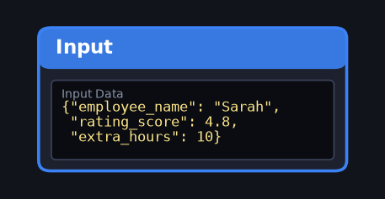
Input block with the value entered

Step 2 - Map and fill in the blocks
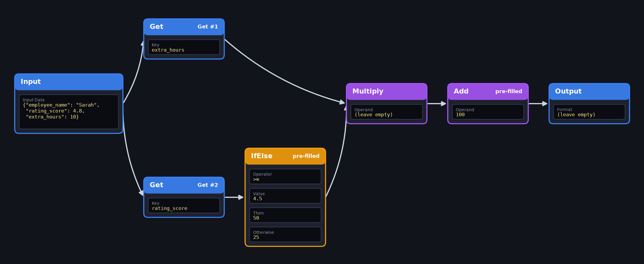
Completed canvas: block connections and field values
- Branch 1 (hours): Input → Get (Key = extra_hours, already filled in for the first Get).
- Branch 2 (hourly rate): Input → Get (Key = rating_score, already filled in for the second Get) → IfElse (already filled in: Operator = >=, Value = 4.5, Then = 50, Otherwise = 25). The rate is $25 per hour, doubled to $50 when Rating >= 4.5.
- Merge: connect the first Get (extra_hours) → Multiply AND IfElse → the same Multiply. Leave the Multiply operand empty; it multiplies hours × rate.
- Multiply → Add (Operand 100 is already filled in: attendance allowance).
- Add → Output.

Step 3 - Check the output
Leave the Output format empty. Run Flow must show 600.0.
Tip: Get keys are pre-filled. Leave the Multiply operand empty: it multiplies hours by rate.

Question 3: School Supplies Budget
Calculate the total bill and check whether the student can afford it.
Input data | {"budget":200,"notebook":80,"pen":30,"pencil_box":100}
Expected output | Budget exceeded by 10
Blocks needed | Input, Get, Sum, Subtract, Output

Step 1 - Enter the input value
Drag an Input node and set Input Data to {"budget": 200, "notebook": 80, "pen": 30, "pencil_box": 100}.
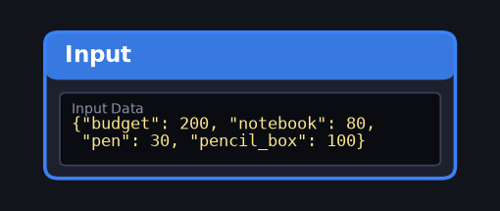
Input block with the value entered

Step 2 - Map and fill in the blocks
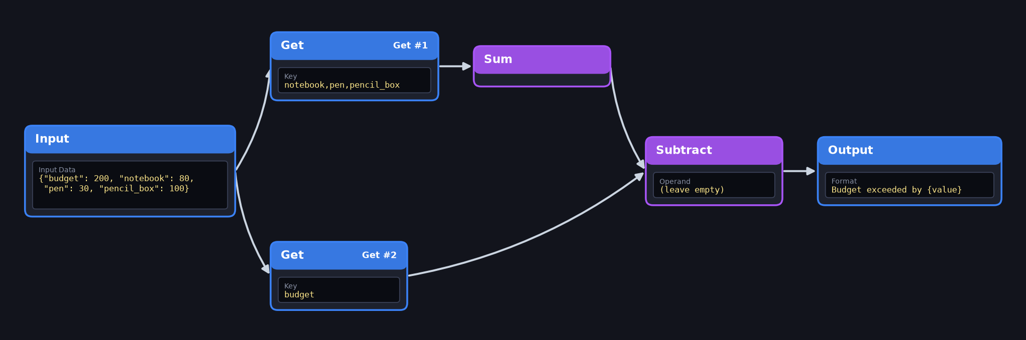
Completed canvas: block connections and field values
- Input → Get #1 (Key notebook,pen,pencil_box is already filled in) → Sum (total bill = 210).
- Input → Get #2 (Key budget is already filled in).
- Connect Sum → Subtract and Get #2 (budget) → Subtract, in either order. Subtract gives the difference (210 and 200 → 10).
- Subtract → Output.

Step 3 - Check the output
The Output format (Budget exceeded by {value}) is already filled in. Run Flow must show Budget exceeded by 10.
Tip: Keys and the Output format are pre-filled, and Subtract gives the difference, so you can connect Sum and the budget Get to Subtract in either order.

Hard level

Question 1: World Landmark Locator
A geography exploration tool identifies a famous world landmark. Given the landmark's name, look up its country and continent from a predefined dataset, determine its hemisphere position (Eastern if longitude >= 0, Northern if latitude >= 0), and render a Location Photo Card showing the landmark's image pinned on a simplified world map.
Input data | Eiffel Tower
Expected output | Country: France | Continent: Europe | Hemisphere: Northern & Eastern Hemisphere
Blocks needed | Input, Lookup, Hemisphere, Output

Step 1 - Enter the input value
Drag an Input node and set Input Data to Eiffel Tower (the landmark name).
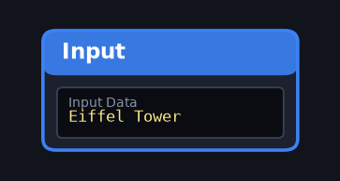
Input block with the value entered

Step 2 - Map and fill in the blocks
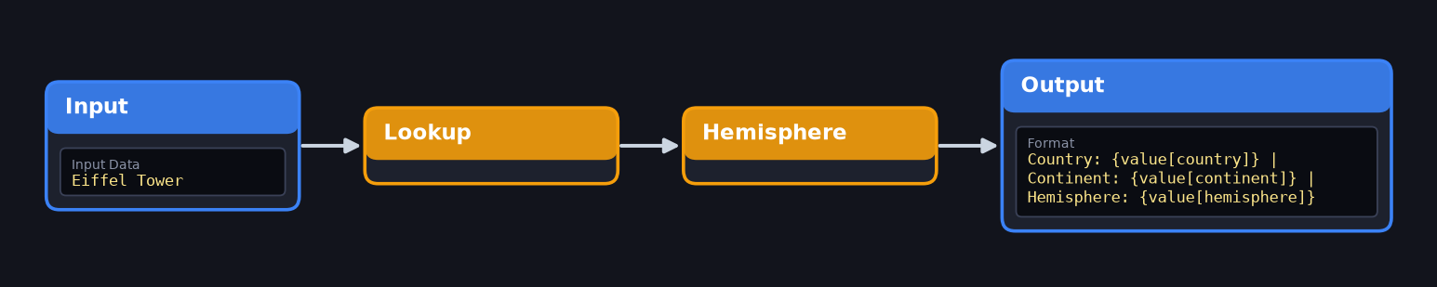
Completed canvas: block connections and field values
- Input → Lookup (finds Country, Continent and coordinates in the predefined table).
- Lookup → Hemisphere (longitude ≥ 0 = Eastern, latitude ≥ 0 = Northern; combines both).
- Hemisphere → Output.

Step 3 - Check the output
Set the Output format to Country: {value[country]} | Continent: {value[continent]} | Hemisphere: {value[hemisphere]}. Run Flow must show Country: France | Continent: Europe | Hemisphere: Northern & Eastern Hemisphere. The reference picture shows the map pin and photo card the tool would draw.
Tip: Lookup finds country, continent and coordinates. Hemisphere combines them. Copy the Output format exactly, including the | separators.

Question 2: Weekly Attendance Chart
A class teacher wants to visualize the attendance of students over five days. Create a line chart using the attendance data, with days on the X-axis, number of students present on the Y-axis, and the chart title "Weekly Attendance".
Input data | {"x":["Monday","Tuesday","Wednesday","Thursday","Friday"],"y":[35,38,36,40,37]}
Expected output | Line chart titled 'Weekly Attendance' with days on the X-axis and students present on the Y-axis
Blocks needed | Input, LineChart, Output

Step 1 - Enter the input value
Drag an Input node and set Input Data to {"x": ["Monday","Tuesday","Wednesday","Thursday","Friday"], "y": [35,38,36,40,37]} (x = days, y = students present).
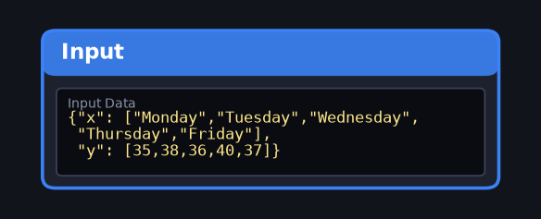
Input block with the value entered

Step 2 - Map and fill in the blocks
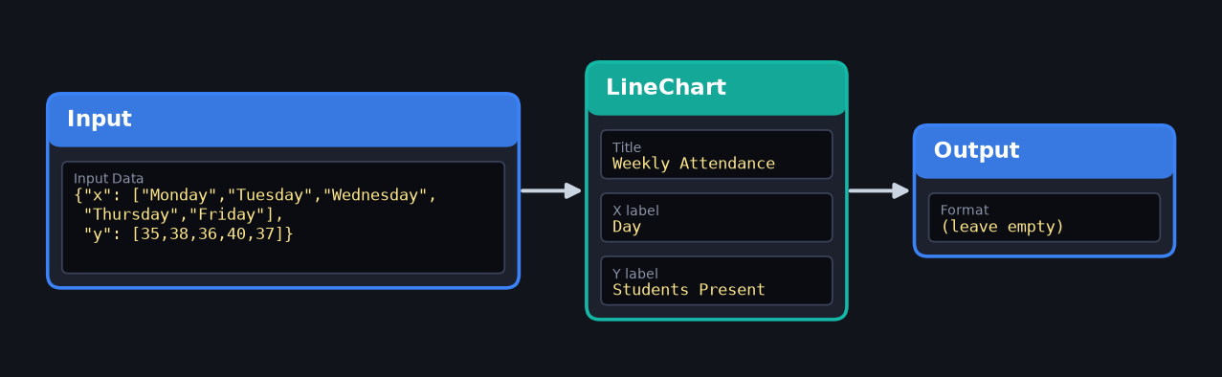
Completed canvas: block connections and field values
- Input → LineChart: open LineChart ⚙ and set Title = Weekly Attendance, X Axis Label = Day, Y Axis Label = Students Present.
- LineChart → Output.

Step 3 - Check the output
Leave the Output format empty. Run Flow must draw the chart titled Weekly Attendance (days on X, students present on Y).
Tip: Fill in all three LineChart fields: Title, X label and Y label. The chart title must be exactly Weekly Attendance.

